$Statistics session-4:$

$Defination of statstics$

$Inferential statistics$

$Descriptive statistics$

$Data types of variables$

$Levels of data$

$Popuation vs sample$

$Frequency table$

$Bar chart$

$Relative frequency table$

$Pie chart$

$Frequency distribution table$

$Histogram$

$Data distribution$

$How to make CI and width$

$Central tendency$

$Mean-Medain-Mode$

$Mean vs Medain$

$Outliers$

$Exact meaning of Mode in Distributions$

$Types of Distributions$

$Postive skew$

$Negative skew$

$No skew$

$Range:$

$Range will give how a data is distributed from starting point to ending point$

$Consider student marks 1 mark , ending with 99 marks$

$so that the data is flowing from 1 mark to 99 marks$

$Lowest=1 highest=99$

$Range=H-L=99-1=98$

$Draw back: It will not Consider middile values$

$Mean deviation:$

$How a data point is deviated from mean$

$assume that 1,2,3,4,5 are the values$

$Mean value \underline{x}=3$

$x_{1}=1 ,x_{2}=2,x_{3}=3,x_{4}=4 ,x_{5}=5$

$The deviation of x_{1} from \underline{x} =\left(x_{1}-\underline{x}\right)=1-3=-2$

$The deviation of x_{2} from \underline{x} =\left(x_{2}-\underline{x}\right)=2-3=-1$

$The deviation of x_{3} from \underline{x} =\left(x_{3}-\underline{x}\right)=3-3=0$

$The deviation of x_{4} from \underline{x} =\left(x_{4}-\underline{x}\right)=4-3=1$

$The deviation of x_{5} from \underline{x} =\left(x_{5}-\underline{x}\right)=5-3=2$

$-2 x_{1} has 2 units below from the mean point$

$2 x_{5} has 2 units ahead from the mean point$

$Total deviation:$

$\frac{1}{5}*\left[\left(x_{1}-\underline{x}\right)+\left(x_{2}-\underline{x}\right)+\left(x_{3}-\underline{x}\right)+\left(x_{4}-\underline{x}\right)+\left(x_{5}-\underline{x}\right)\right]=\frac{1}{5}*\sum_{i=1}^{5}{}\left(x_{i}-\underline{x}\right)$

$Suppose there are N points are there$

$Mean Deviation: \frac{1}{N}*\sum_{i=1}^{N}{}\left(x_{i}-\underline{x}\right)$

$Draw back :$

$we are seeing individual observations has deviation$

$but when we add all the deviations it might becomes zero$

$\frac{1}{5}*\left[\left(x_{1}-\underline{x}\right)+\left(x_{2}-\underline{x}\right)+\left(x_{3}-\underline{x}\right)+\left(x_{4}-\underline{x}\right)+\left(x_{5}-\underline{x}\right)\right]=\frac{1}{5}*\left[-2-1+0+1+2\right]=0$

$Mohith and shuvendu$

$Mohith===bcz of-values and+values total value=0$

$we will conver-to+1$

$shuvendu :who will conver-to+$

$multiply by -$

$modulus$

$square root$

$Absolute Mean deviation:$

$x becomes \left|x\right|$

$x =-2 becomes \left|-2\right|=2$

$How a data point is deviated from mean$

$assume that 1,2,3,4,5 are the values$

$Mean value \underline{x}=3$

$x_{1}=1 ,x_{2}=2,x_{3}=3,x_{4}=4 ,x_{5}=5$

$The deviation of x_{1} from \underline{x} =|x_{1}-\underline{x|}=\left|1-3\right|=\left|-2\right|=2$

$The deviation of x_{2} from \underline{x} =|x_{2}-\underline{x|}=\left|2-3\right|=\left|-1\right|=1$

$The deviation of x_{3} from \underline{x} =|x_{3}-\underline{x|}=\left|3-3\right|=\left|0\right|=0$

$The deviation of x_{4} from \underline{x} =|x_{4}-\underline{x|}=\left|4-3\right|=\left|1\right|=1$

$The deviation of x_{5} from \underline{x} =|x_{5}-\underline{x|}=\left|5-3\right|=\left|2\right|=2$

$\frac{1}{5}*\left[|\left(x_{1}-\underline{x}\right)|+|\left(x_{2}-\underline{x}\right)|+|\left(x_{3}-\underline{x}\right)|+|\left(x_{4}-\underline{x}\right)|+|\left(x_{5}-\underline{x}\right)|\right]=\frac{1}{5}*\sum_{i=1}^{5}{}|x_{5}-\underline{x|}$

$Suppose there are N points are there$

$Absolute Mean Deviation: \frac{1}{N}*\sum_{i=1}^{N}{}|x_{i}-\underline{x|}$

$\left|X\right|$

| X | |x| |
| --- | --- |
| -3 | 3 |
| -2 | 2 |
| -1 | 1 |
| 0 | 0 |
| 1 | 1 |
| 2 | 2 |
| 3 | 3 |

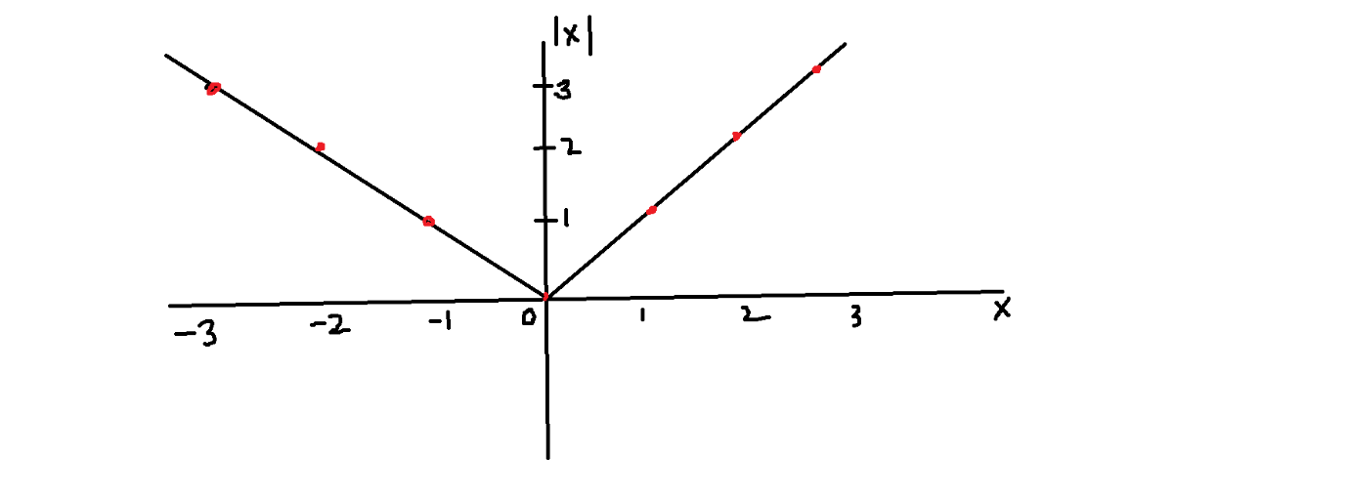

|x| : power = 1 ==== > line as straight line : Linear



$\left|x\right| is not continoues at point=0 , we are stopping at zero$

$any math equation fail because of non continoues$

$If you take the differentitation of \left|x\right|=\frac{x}{\left|x\right|}$

$x=\frac{0}{\left|0\right|}=indeteriminant \left( Not defined\right)$

$Continues equations are good===Discontinue equations are Not good$

$Variance:$

$x becomes x^{2}$

$x =-2 becomes 2^{2}=4$

$How a data point is deviated from mean$

$assume that 1,2,3,4,5 are the values$

$Mean value \underline{x}=3$

$x_{1}=1 ,x_{2}=2,x_{3}=3,x_{4}=4 ,x_{5}=5$

$The deviation of x_{1} from \underline{x} ={\left(x_{1}-\underline{x}\right)}^{2}={\left(1-3\right)}^{2}={\left(-2\right)}^{2}=4$

$The deviation of x_{2} from \underline{x} ={\left(x_{2}-\underline{x}\right)}^{2}={\left(2-3\right)}^{2}={\left(-1\right)}^{2}=1$

$The deviation of x_{3} from \underline{x} ={\left(x_{3}-\underline{x}\right)}^{2}={\left(3-3\right)}^{2}={\left(0\right)}^{2}=0$

$The deviation of x_{4} from \underline{x} ={\left(x_{4}-\underline{x}\right)}^{2}={\left(4-3\right)}^{2}={\left(1\right)}^{2}=1$

$The deviation of x_{5} from \underline{x} ={\left(x_{5}-\underline{x}\right)}^{2}={\left(5-3\right)}^{2}={\left(2\right)}^{2}=4$

$\frac{1}{5}*\left[{\left(x_{1}-\underline{x}\right)}^{2}+{\left(x_{2}-\underline{x}\right)}^{2}+{\left(x_{3}-\underline{x}\right)}^{2}+{\left(x_{4}-\underline{x}\right)}^{2}+{\left(x_{5}-\underline{x}\right)}^{2}\right]=\frac{1}{5}*\sum_{i=1}^{5}{}{\left(x_{i}-\underline{x}\right)}^{2}$

$Suppose there are N points are there$

$Variance: \frac{1}{N}*\sum_{i=1}^{N}{}{\left(x_{i}-\underline{x}\right)}^{2}$

| X | X^2 |
| --- | --- |
| -3 | 9 |
| -2 | 4 |
| -1 | 1 |
| 0 | 0 |
| 1 | 1 |
| 2 | 4 |
| 3 | 9 |

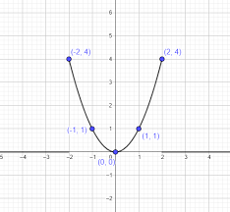

X^2 : power = 2 ==== > parabola :Non- Linear

$Range=H-L$

$Mean Deviation: \frac{1}{N}*\sum_{i=1}^{N}{}\left(x_{i}-\underline{x}\right)$

$Absolute Mean Deviation: \frac{1}{N}*\sum_{i=1}^{N}{}|x_{i}-\underline{x|}$

$Variance: \frac{1}{N}*\sum_{i=1}^{N}{}{\left(x_{i}-\underline{x}\right)}^{2}$

$Data means a distribution$

$In order to undersatnd the distributions we have two methods$

$Central tendency:Mean-Median-mode$

$Data dispersion$

$Range : It will not consider the middile values$

$Mean divaition:The sum of total diviations becomes zero$

$Absolute mean deviation:\left|x\right| has dicontinue at zero$

$Variance$

$Range=H-L$

$Mean Deviation: \frac{1}{N}*\sum_{i=1}^{N}{}\left(x_{i}-\underline{x}\right)$

$Absolute Mean Deviation: \frac{1}{N}*\sum_{i=1}^{N}{}|x_{i}-\underline{x|}$

$Variance: \frac{1}{N}*\sum_{i=1}^{N}{}{\left(x_{i}-\underline{x}\right)}^{2}$

$Draw back in the variance:$

| Distance(x) | $x-\underline{x}$ | ${\left(x-\underline{x}\right)}^{2}$ |
| --- | --- | --- |
| 1km | 1km-3km=-2km | (-2km)^2= 4km^2 |
| 2km | 2km-3km=-1km | 1km^2 |
| 3km | 3km-3km=0km | 0km^2 |
| 4km | 4km-3km=1km | 1km^2 |
| 5km | 5km-3km=2km | 4km^2 |
| Average=3km ( $\underline{x})$ |  | 10km^2 |

$\frac{1}{N}*\sum_{i=1}^{N}{}{\left(x_{i}-\underline{x}\right)}^{2}=\frac{1}{5}*\left[4km^{2}+1km^{2}+0km^{2}+1km^{2}+4km^{2}\right]=\frac{10km^{2}}{5}=2km^{2}$

$In above calculation the variance=2km^{2}$

$It is not increaseing the vlaues but also It is changing the units into square terms$

$We will not able to proper interpretaion$

$Standrad deviation:$

$denoted with 'σ'$

$σ=\sqrt{variance}$

$std=σ=\sqrt{\frac{1}{N}*\sum_{i=1}^{N}{}{\left(x_{i}-\underline{x}\right)}^{2}}$

$How much distance between Hyd to Blr :600km$

$How much a data point is deviated from mean point$

$std=σ=\sqrt{2km^{2}}=1.41km$

$Range=H-L$

$Mean Deviation: \frac{1}{N}*\sum_{i=1}^{N}{}\left(x_{i}-\underline{x}\right)$

$Absolute Mean Deviation: \frac{1}{N}*\sum_{i=1}^{N}{}|x_{i}-\underline{x|}$

$Variance: \frac{1}{N}*\sum_{i=1}^{N}{}{\left(x_{i}-\underline{x}\right)}^{2}$

$std=σ=\sqrt{\frac{1}{N}*\sum_{i=1}^{N}{}{\left(x_{i}-\underline{x}\right)}^{2}}$